**IBM Application Discovery and Delivery Intelligence (ADDI)**

## Scenario-1: Access and Improve the maintainability of a Cobol Application

Generated a detailed report for unused codes –

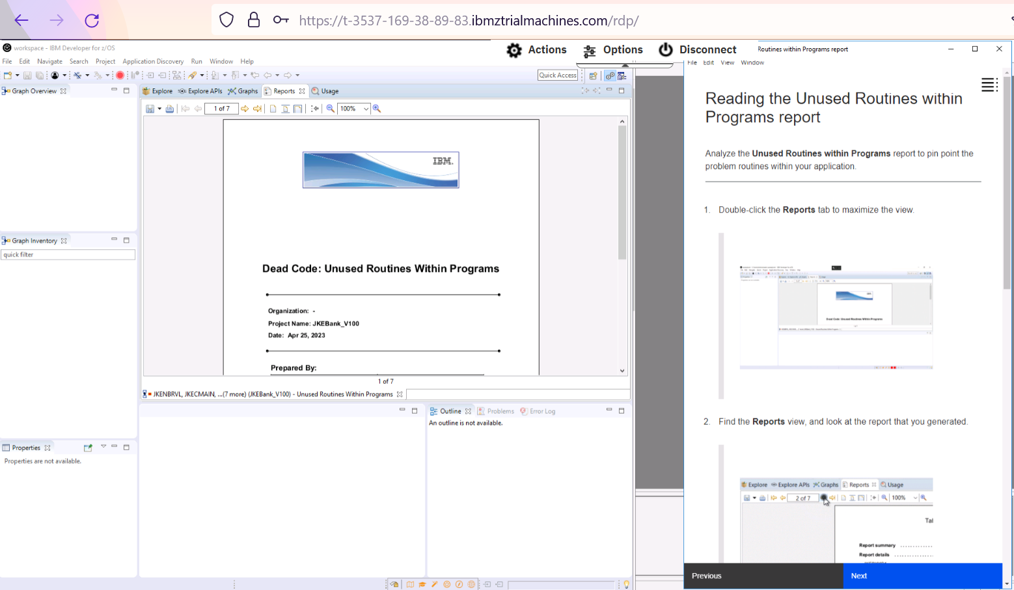

Reading the unused routines within program report

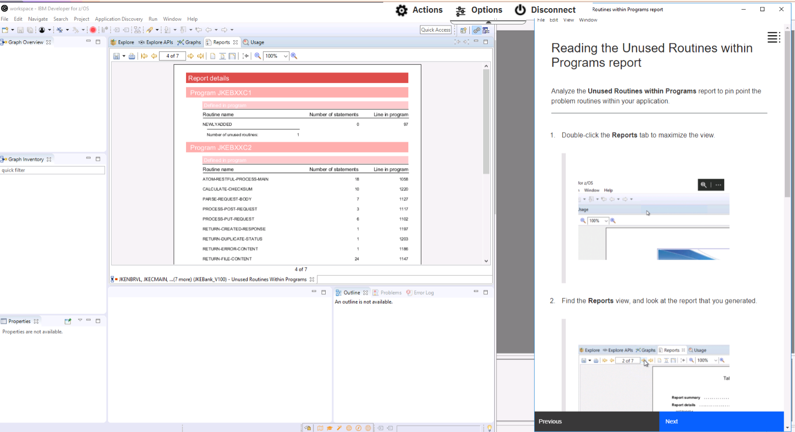

Identify the unused routines in a program flow graph

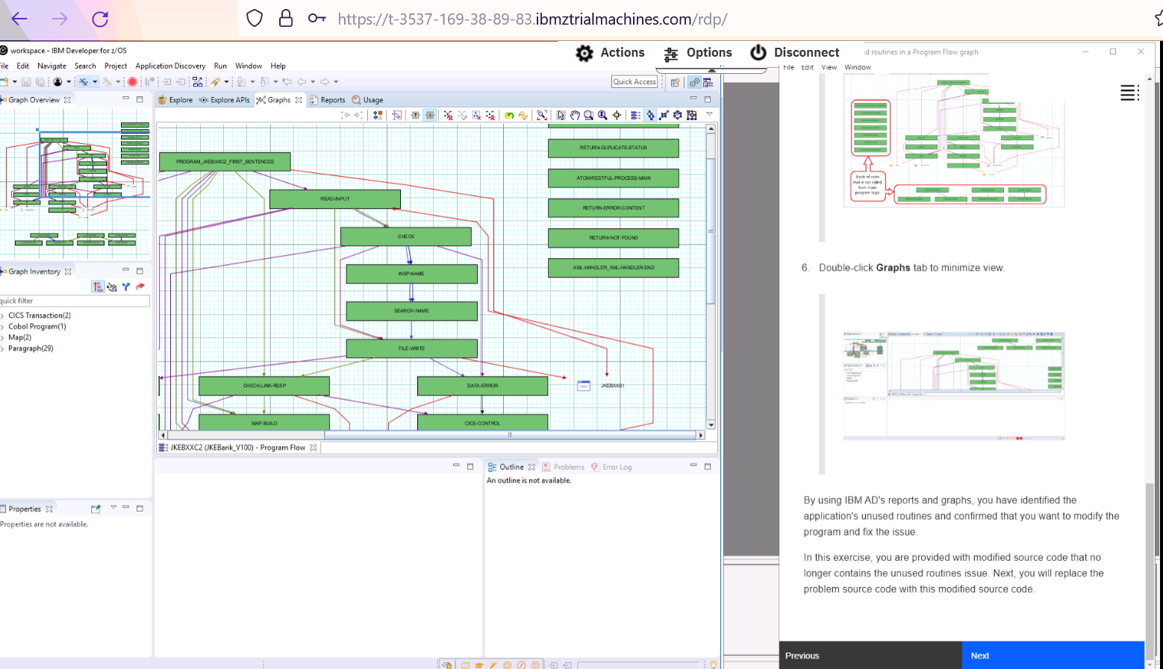

Overwriting source code to eliminate problematic routines

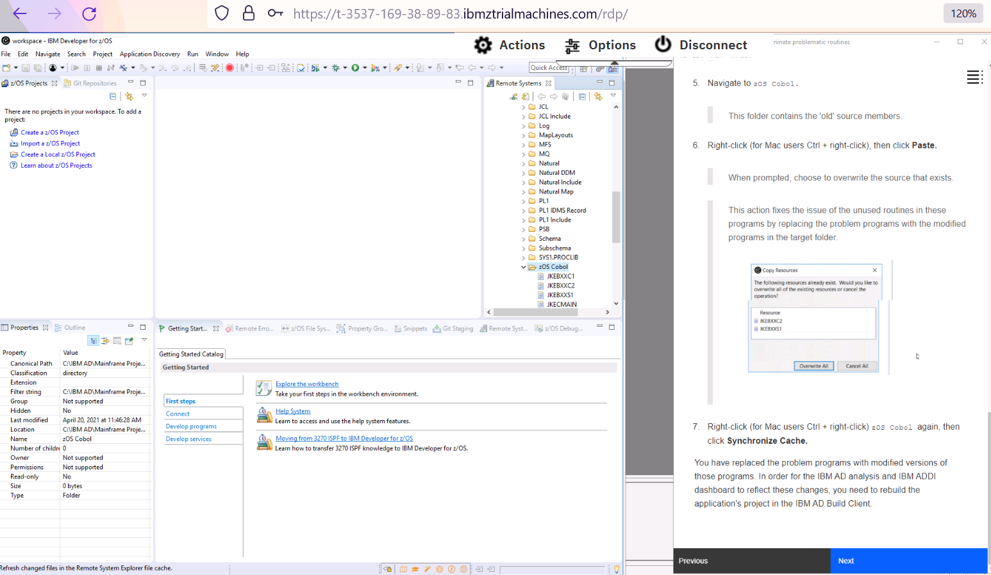

Rebuilding the project in the repository

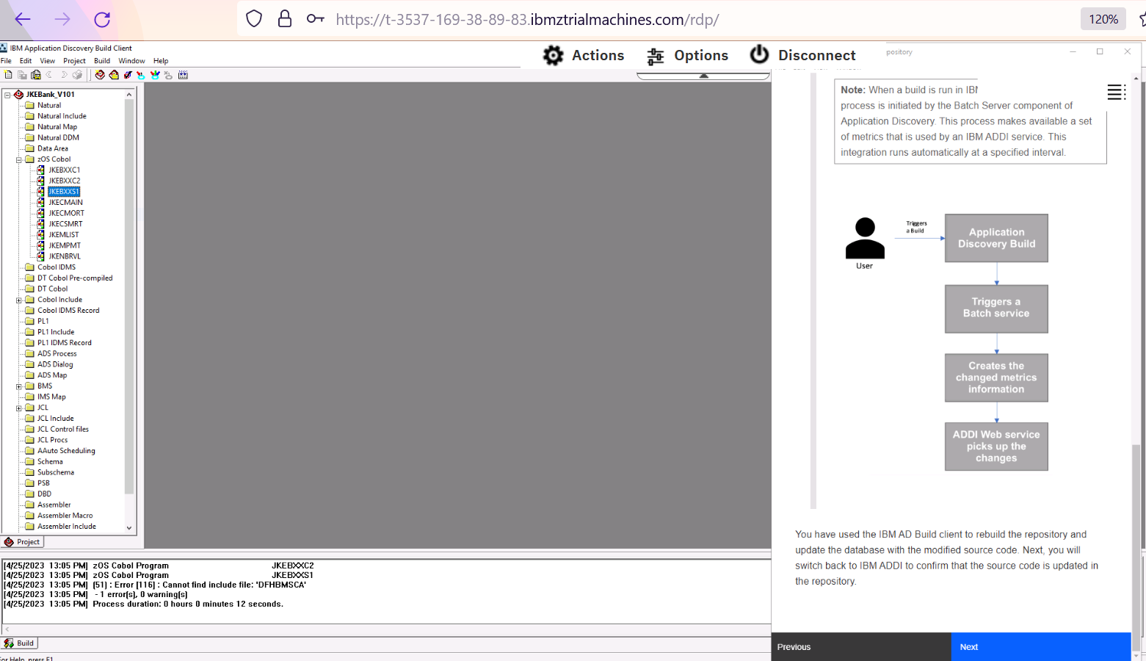

Confirming that the source code is updated in the repository

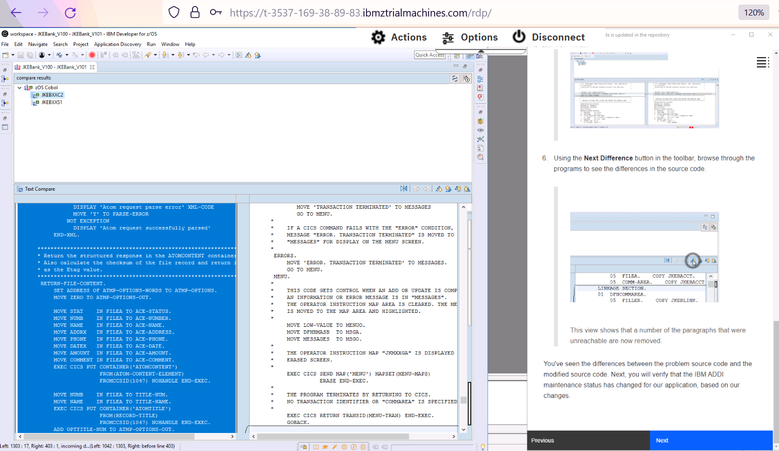

Updating Application Discovery & Delivery Intelligence

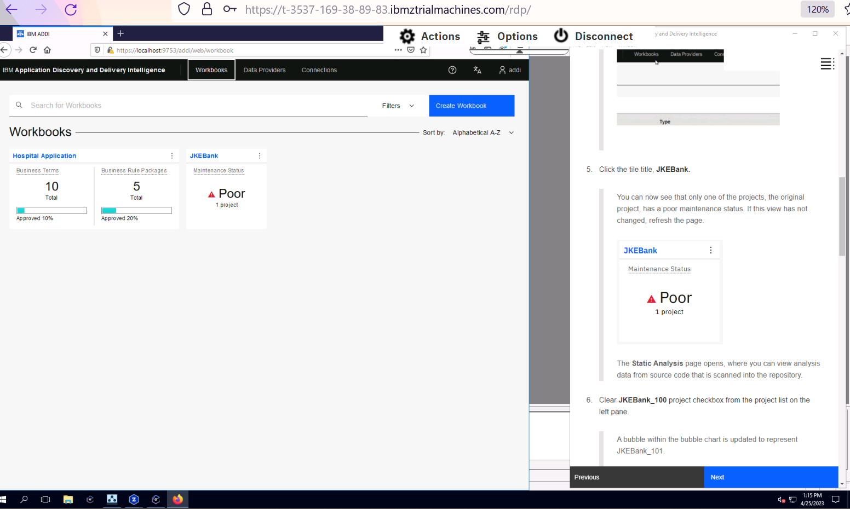

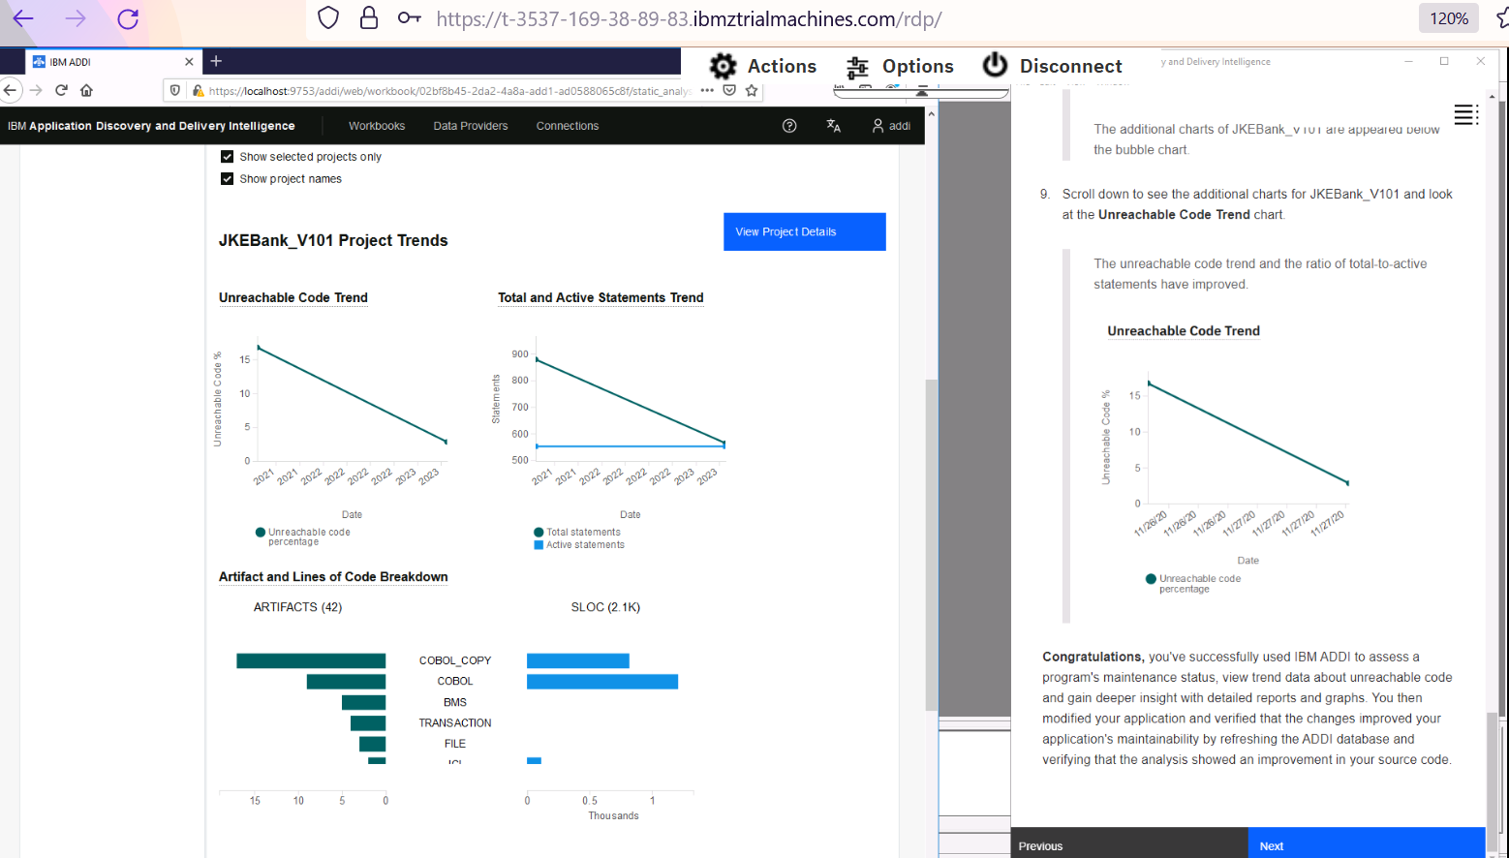

## Scenario-2: Discover Candidate APIs in your code base

Discovering the Application

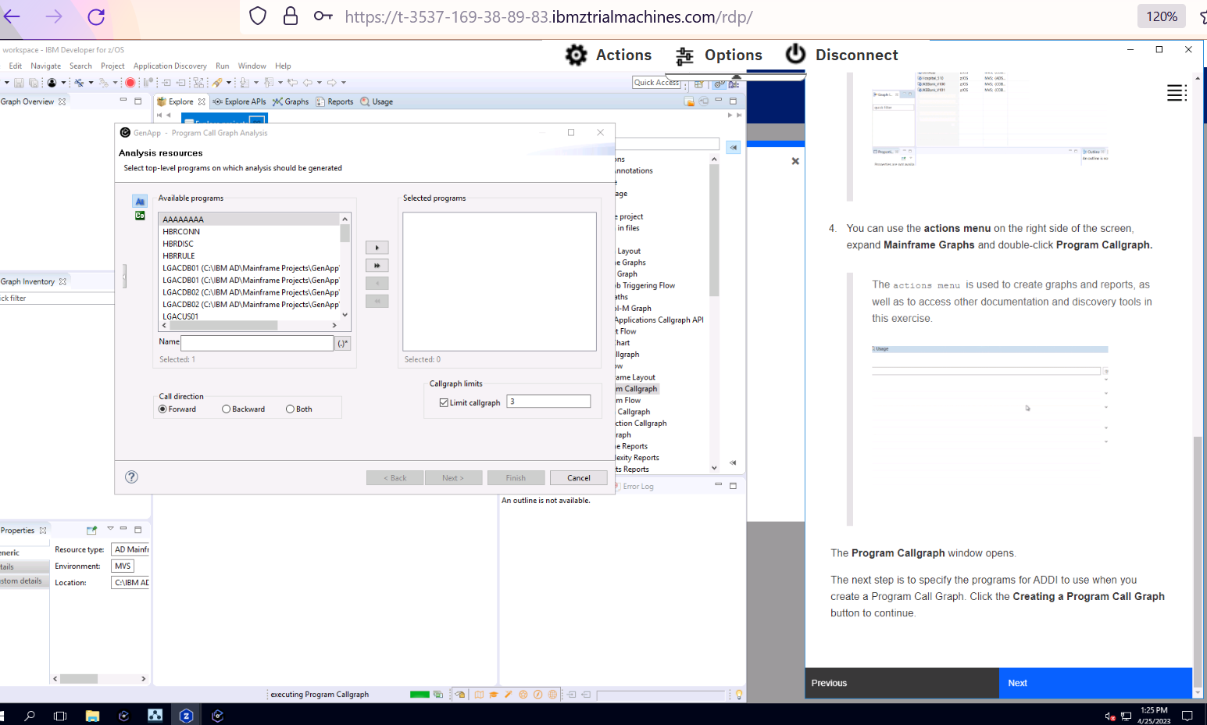

Creating a Program Call graph

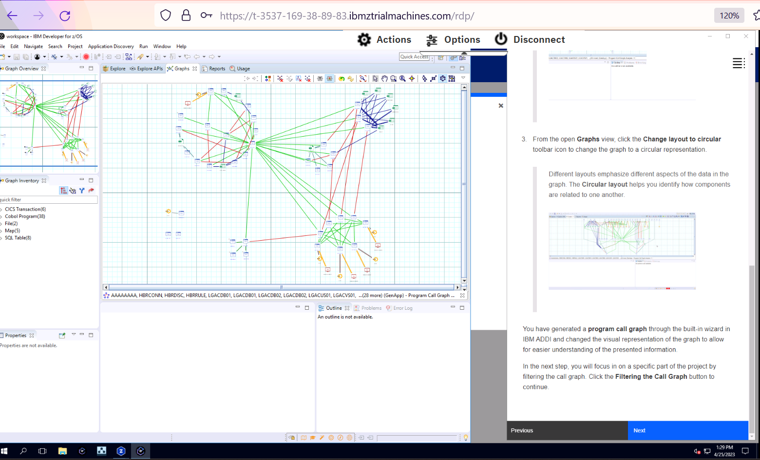

Filtering the call graph

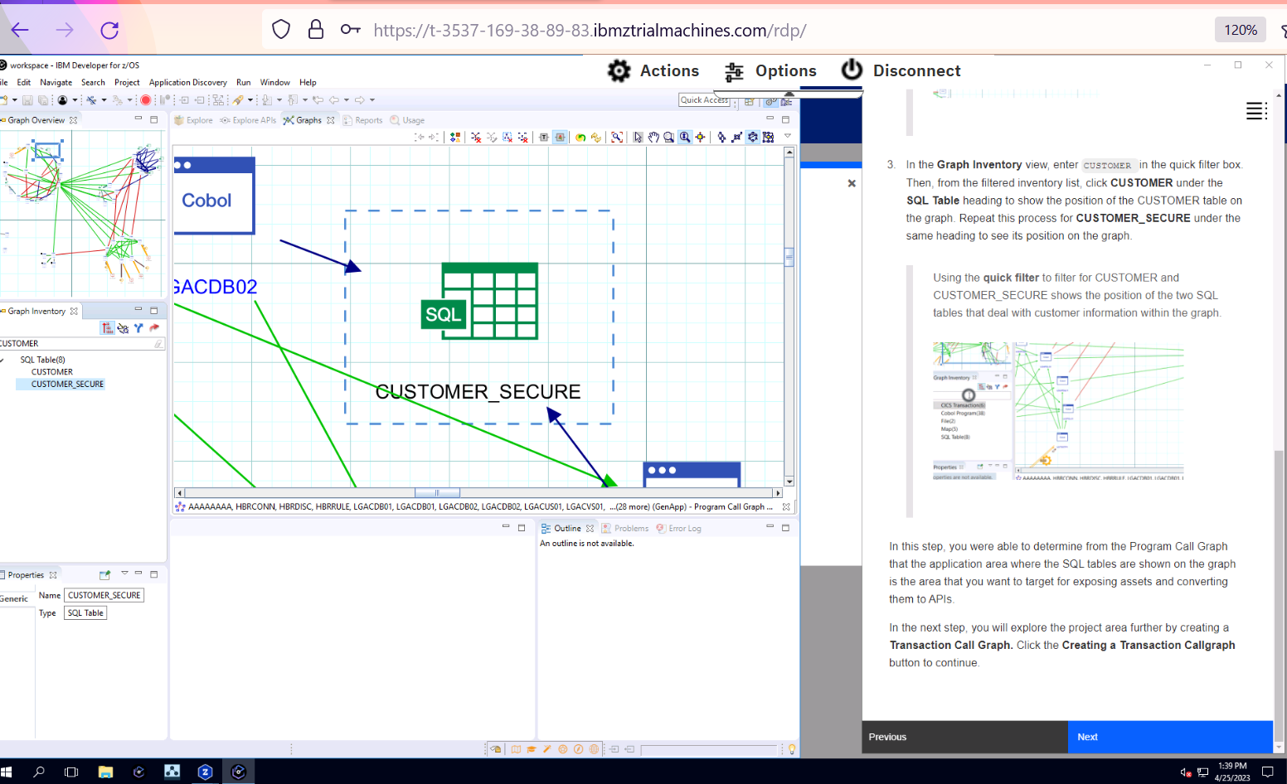

Verifying processes within code

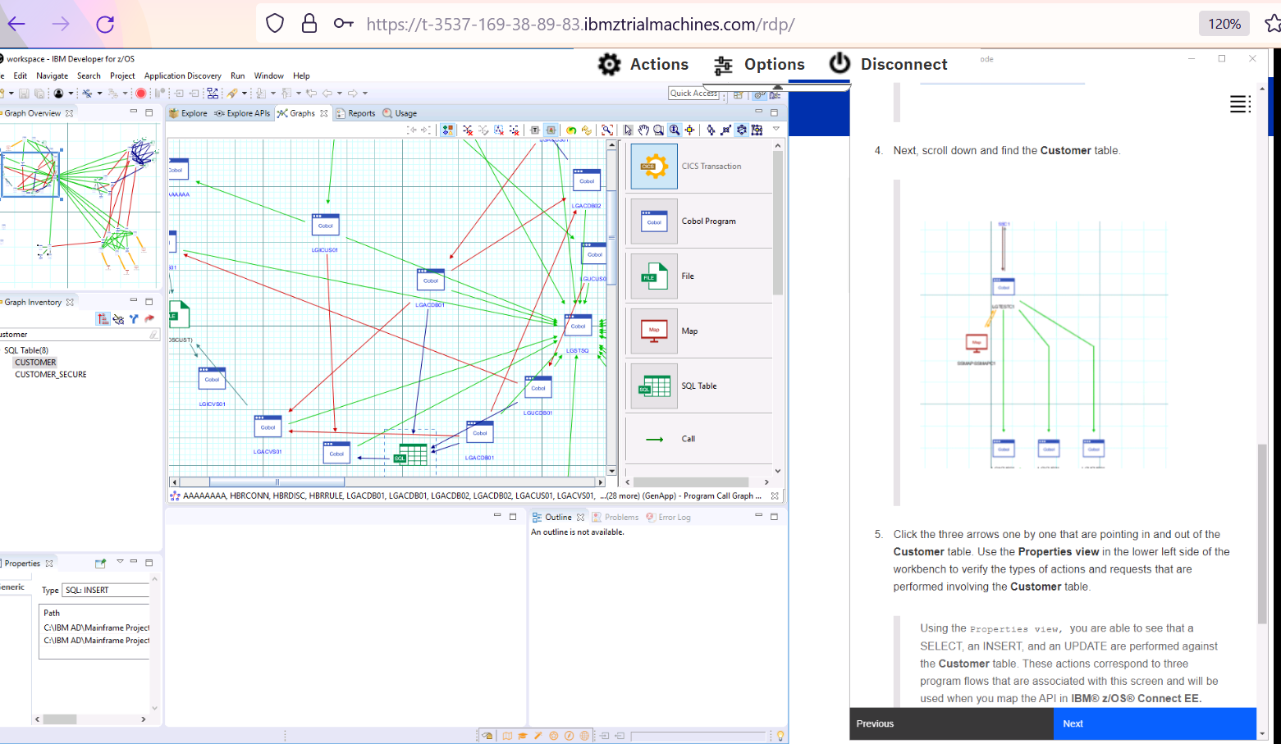

Creating a program flow graph

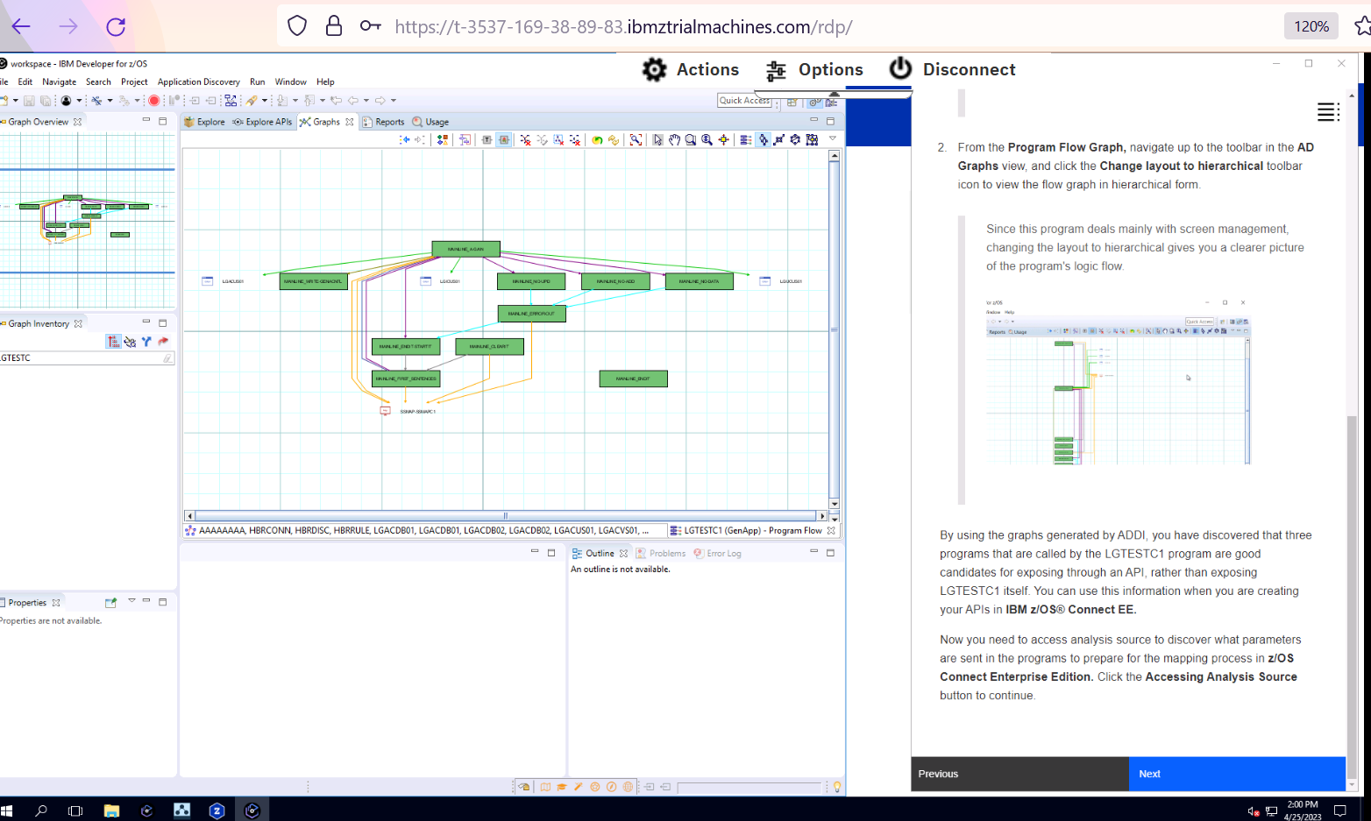

Accessing Analysis Source

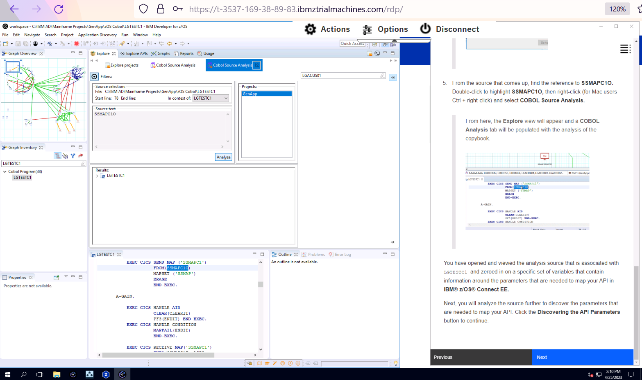

Discovering the API parameter

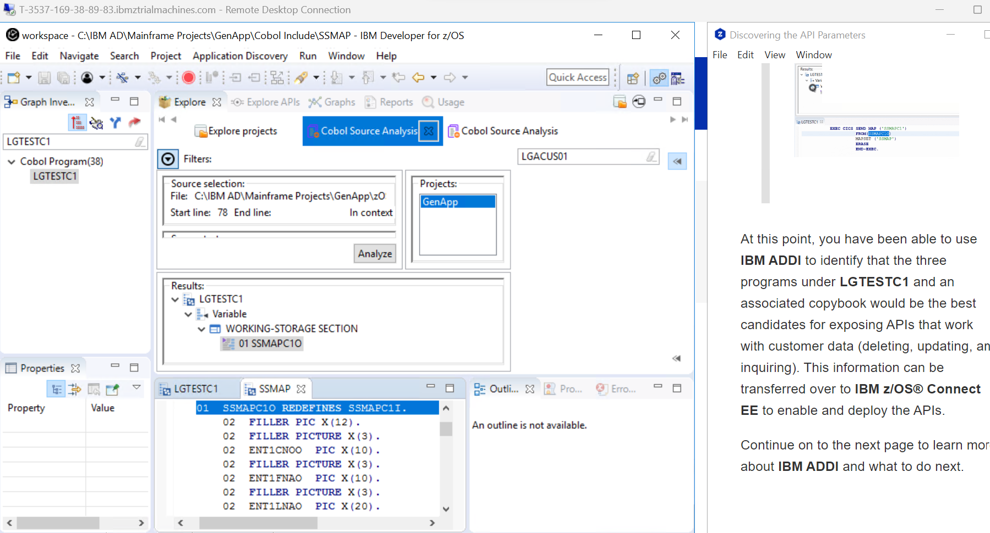

## Scenario-3: View business terms and business rule packages inventory

Review the business term catalogue

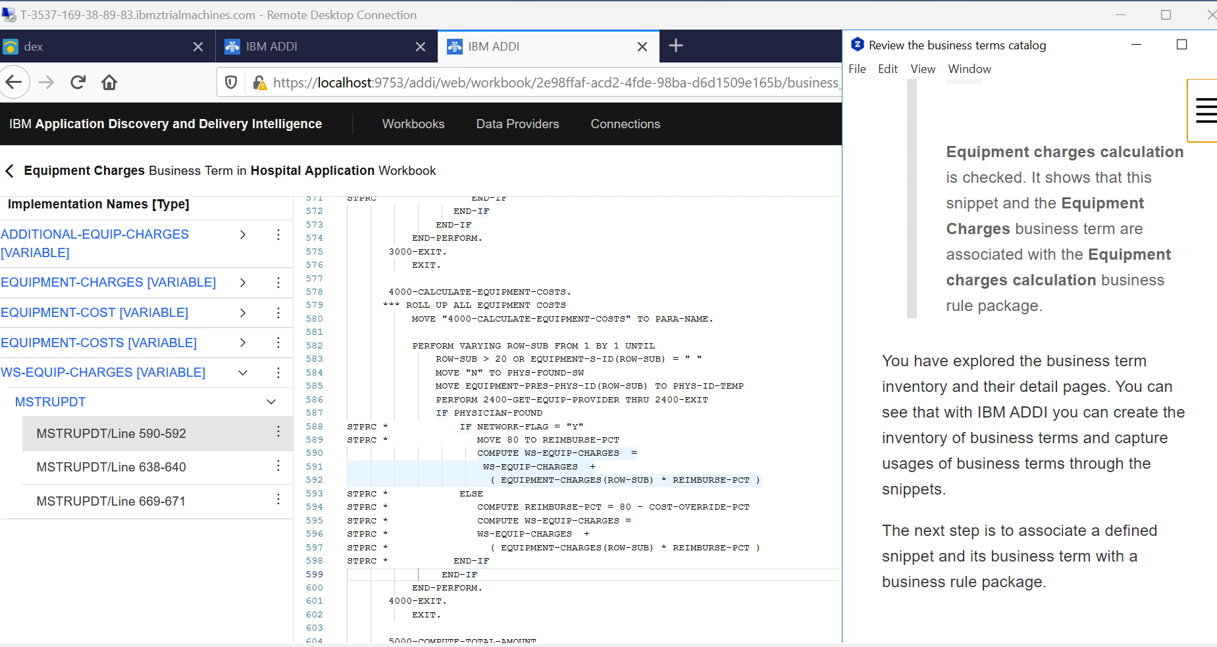

Associate a business term with a business rule package through an already defined snippet

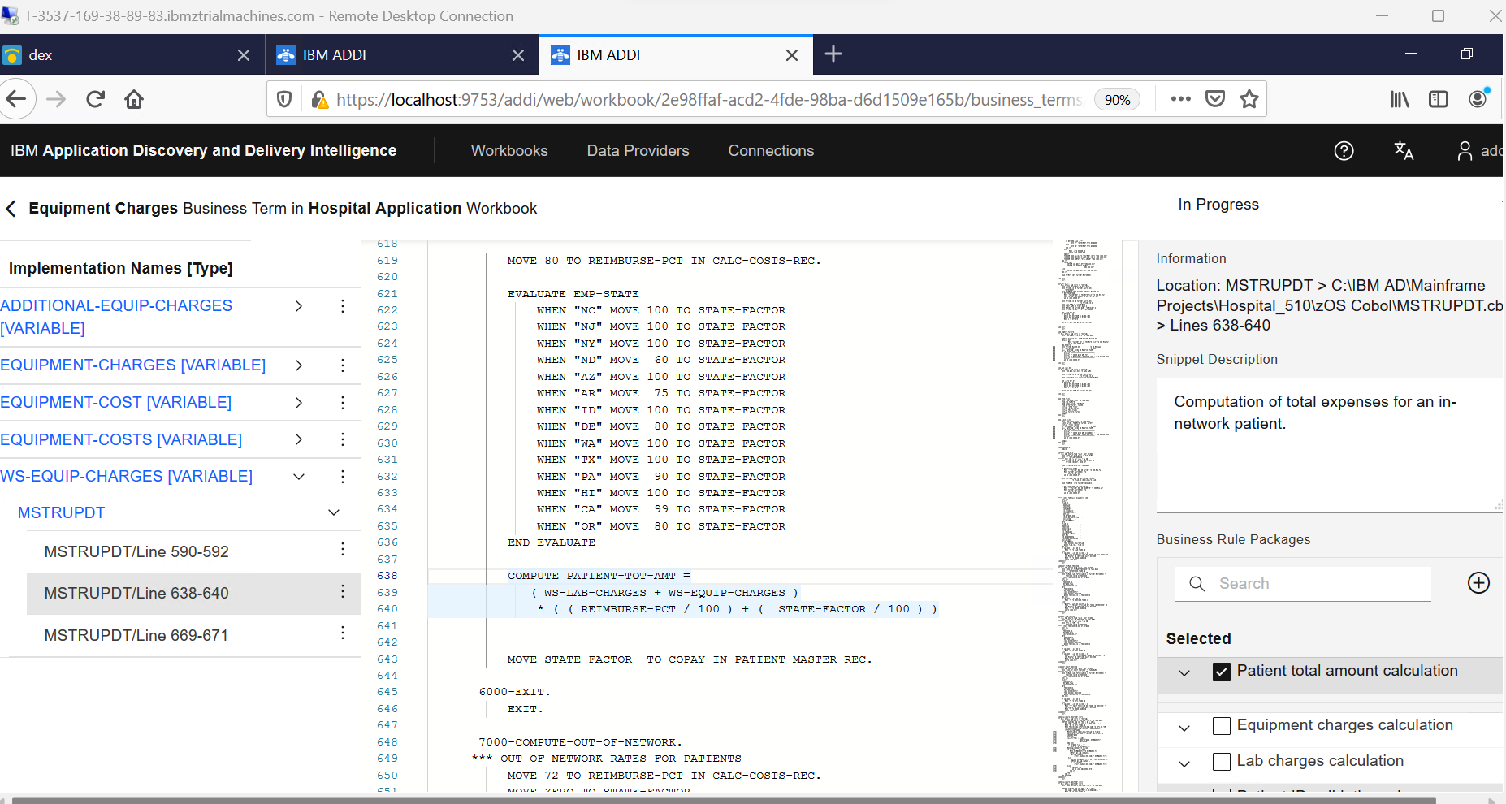

Review the Business Rule package catalogue

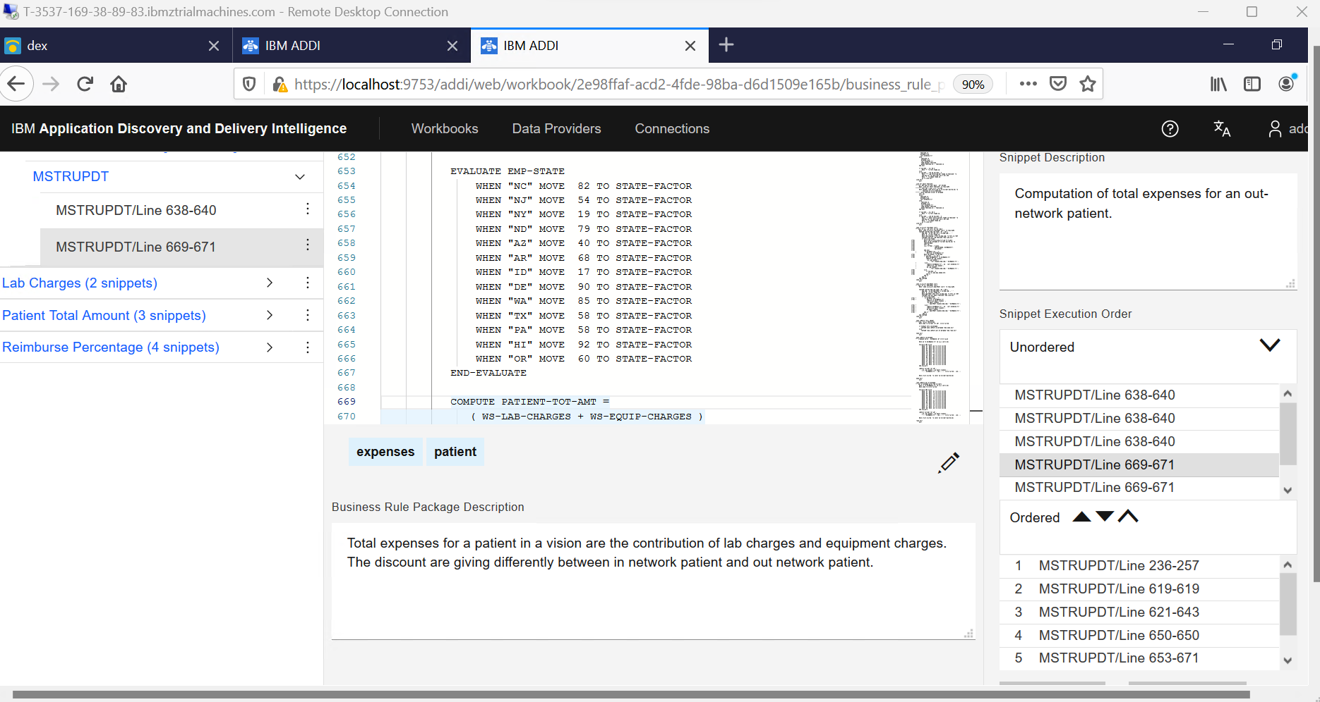

Manage Snippet execution order

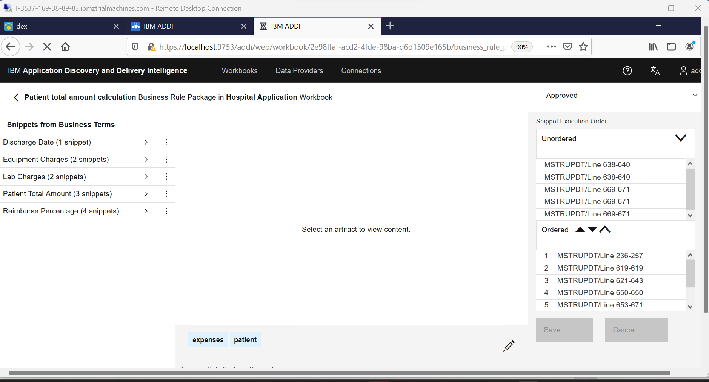

## Scenario-4: Discover business terms and business logics through keyword analysis

View the list of keywords recommended by IBM ADDI & their detail summary

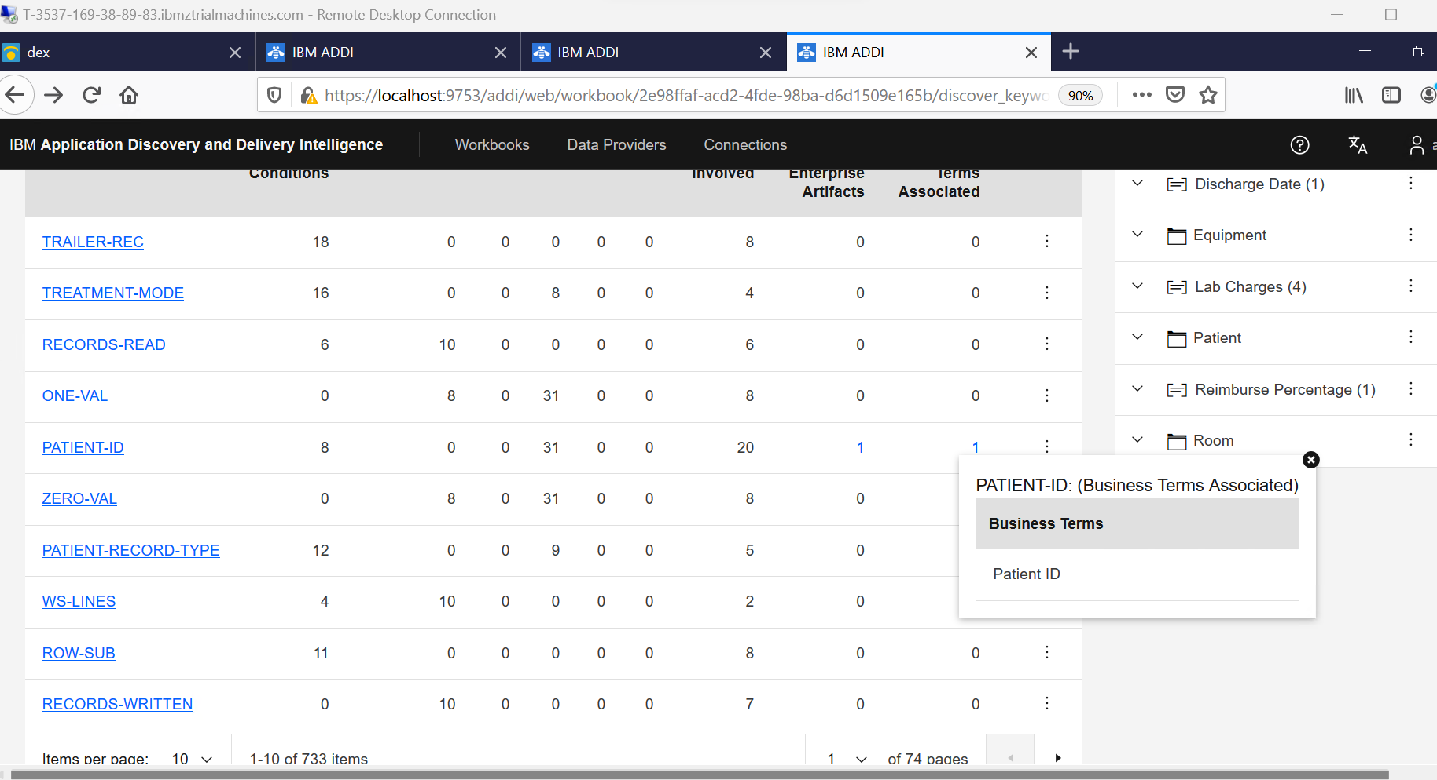

Discover a business term and business logic from keyword detail page

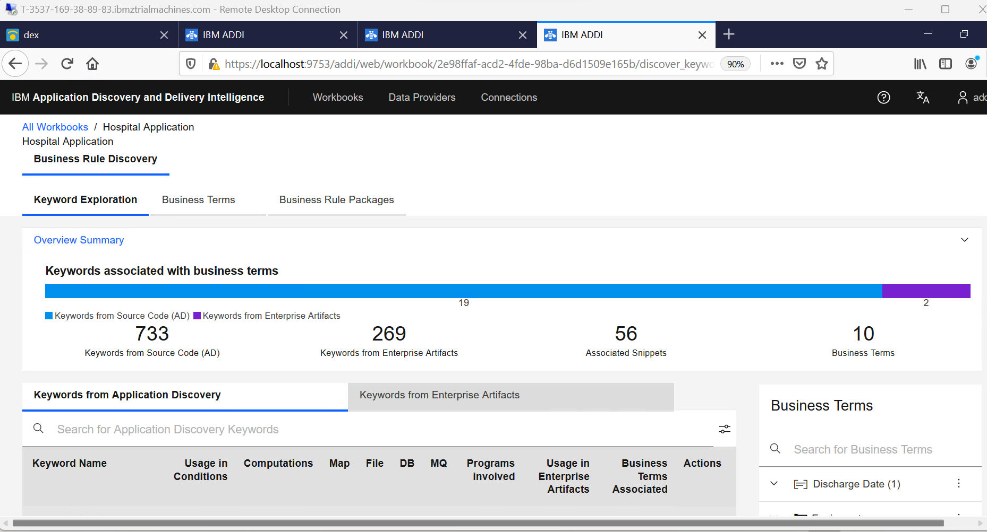

Discover business terms from enterprise artifacts

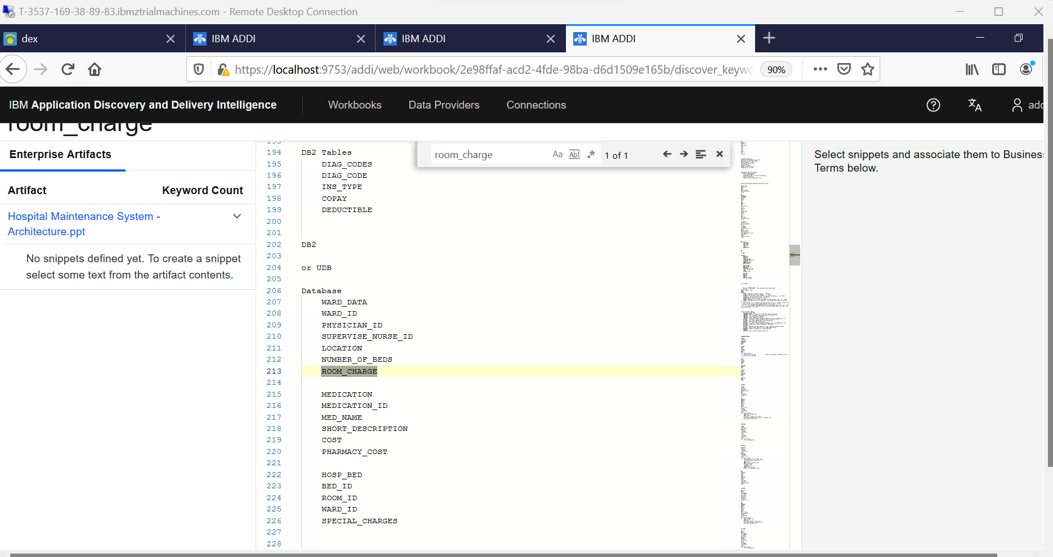

Search keywords to identify new terms

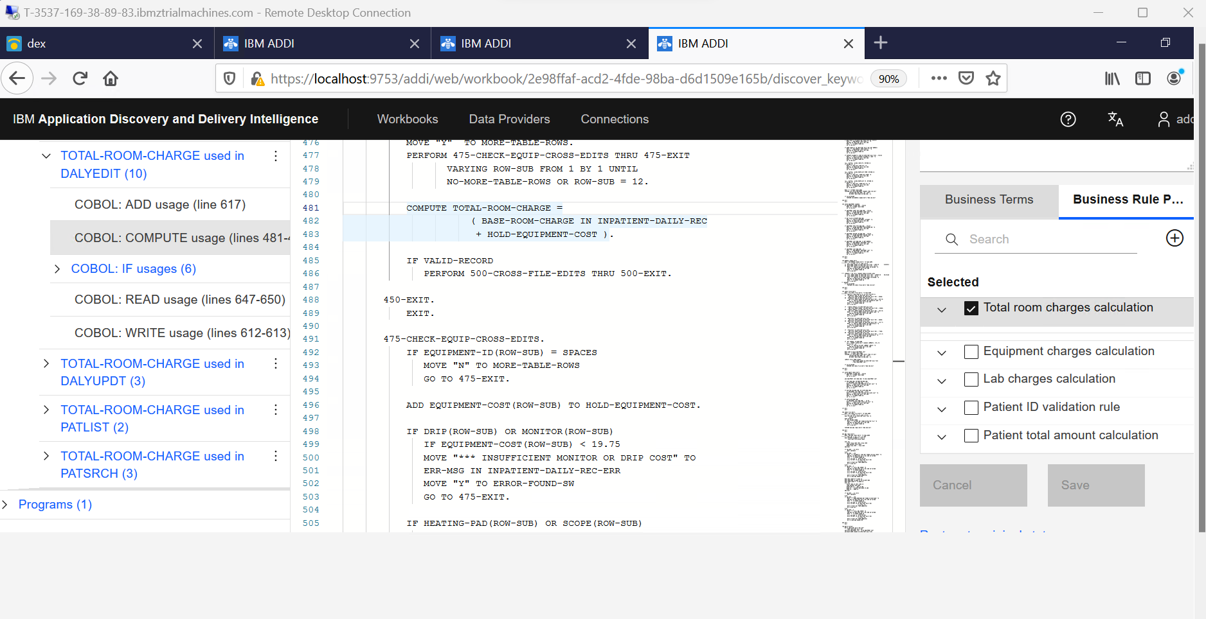

Identify additional business terms through keyword affinity

